PROJECT REPORT
Implement Client Script & UI Policy - Incident (ServiceNow)
Project Name | Implement Client Script & UI Policy - Incident (ServiceNow)
Platform | ServiceNow (Incident Management)
Team ID | 6ab27553ba33564c8ba14e60
Team Members | Abinayashree P  Afrafathima S  Alagu Sevani N  Ani Rosita M  Anusiya U
Date | 29 September 2026

Project Report Format
1. INTRODUCTION
1.1 Project Overview
1.2 Purpose
2. IDEATION PHASE
2.1 Problem Statement
2.2 Empathy Map Canvas
2.3 Brainstorming
3. REQUIREMENT ANALYSIS
3.1 Customer Journey map
3.2 Solution Requirement
3.3 Data Flow Diagram
3.4 Technology Stack
4. PROJECT DESIGN
4.1 Problem Solution Fit
4.2 Proposed Solution
4.3 Solution Architecture
5. PROJECT PLANNING & SCHEDULING
5.1 Project Planning
6. FUNCTIONAL AND PERFORMANCE TESTING
6.1 Performance Testing
7. RESULTS
7.1 Output Screenshots
8. ADVANTAGES & DISADVANTAGES
9. CONCLUSION
10. FUTURE SCOPE
11. APPENDIX
Source Code (if any)
Dataset Link
GitHub & Project Demo Link

1. INTRODUCTION

1.1 Project Overview
ServiceNow is a cloud-based platform used by organizations to manage IT services, including Incident Management. In a real IT environment, Incident records are handled by many users at different levels. Without proper validation and automation on the Incident form, incorrect or incomplete data can be entered, important fields can be left empty, and records can be modified in ways that break the standard workflow.
This project, Implement Client Script & UI Policy - Incident, controls the Incident form using ServiceNow configuration tools. A UI Policy makes the Assignment Group mandatory and the Urgency field read-only when the Impact is High. Client Scripts automatically set the Urgency, stop saving when Assigned To is empty, and stop State changes from the Incident list.

1.2 Purpose
The purpose of the project is to make the Incident form easier to use and less error-prone, to make sure that High Impact Incidents always have proper assignment details, and to make State changes follow a controlled path through the Incident form.
The objectives of the project are:
- To create and configure a UI Policy for High Impact Incidents.
- To make Assignment Group mandatory and Urgency read-only when Impact is High.
- To automatically set Urgency when Impact is High.
- To prevent saving an Incident when Assigned To is empty.
- To prevent direct State changes from the Incident list and allow them through the Incident form.
- To test all the implemented configurations.

2. IDEATION PHASE

2.1 Problem Statement
In the existing system, the Urgency field has to be set manually even when the Impact is High, the Assignment Group is not enforced as mandatory, and the State field can be edited directly from the Incident list without any restriction. This leads to incomplete records, missing assignment information, and inconsistent State changes.
Problem Statement (PS) | I am (Customer) | I'm trying to | But | Because | Which makes me feel
PS-1 | A service desk agent | create and update Incident records with complete and correct details | Urgency is set manually, Assignment Group and Assigned To can be left empty for High Impact Incidents | the Incident form has no validation or automation for High Impact | that records are incomplete and I may miss important assignment information
PS-2 | A ServiceNow administrator | keep Incident records consistent for all users | State can be edited directly from the Incident list without any restriction | there is no control on list editing of the State field | that the standard workflow can be broken and State values become inconsistent

2.2 Empathy Map Canvas
The empathy map is prepared for the primary user of the project, the service desk agent who works on Incident records.
Says | Thinks
“The Urgency has to be set again and again for High Impact.”  “Who is this Incident assigned to?” | I must not leave important fields empty.  The record should follow the standard process.
Does | Feels
Creates and updates Incident records.  Edits the State directly from the Incident list.  Sets Urgency manually. | Careful about incomplete records.  Confused when assignment details are missing.
Pains | Gains
Assignment Group and Assigned To can be left empty.  State changes made from the list break the workflow.  Urgency does not follow Impact automatically. | Instant feedback on the form.  High Impact Incidents always have assignment details.  Clear, controlled path for State changes.

2.3 Brainstorming
Client-side controls were selected because they respond immediately on the form, so the user gets instant feedback without waiting for the record to be saved on the server. The ideas considered are given below.
Idea | Purpose | Decision
UI Policy for High Impact | Make fields mandatory / read-only based on Impact | Selected
onChange Client Script | Auto-set Urgency when Impact changes | Selected
onSubmit Client Script | Check Assigned To before saving | Selected
onCellEdit Client Script | Block State change from the list view | Selected
Target users: service desk agents and support staff who create and update Incident records, and administrators who maintain the Incident form.

3. REQUIREMENT ANALYSIS

3.1 Customer Journey map
The journey of a service desk agent while working on a High Impact Incident, after the solution is implemented:
Stage | Open Incident | Set Impact to High | Submit the record | Update State
User action | Opens Incident > Create New or an existing Incident | Selects Impact as 1 - High | Clicks Submit / Update | Changes State from the form (not from the list)
System response | Standard Incident form is shown | Urgency set to High automatically and made read-only; Assignment Group becomes mandatory | If Assigned To is empty, error message is shown and the record is not saved | State is updated successfully; list editing shows an alert
User feeling | Neutral | Guided - no manual Urgency setting | Informed by a clear message | Confident that the process is controlled

3.2 Solution Requirement
Functional requirements:
FR No. | Functional Requirement (Epic) | Sub Requirement (Story / Sub-Task) | Implemented Using
FR-1 | High Impact Field Control | Assignment Group must be mandatory when Impact is High  Urgency must be read-only when Impact is High  Restrictions must be removed when Impact is no longer High | UI Policy, UI Policy Actions, Reverse if false
FR-2 | Automatic Urgency | Urgency must be set to High automatically when Impact is High | onChange Client Script
FR-3 | Save Validation | Incident must not be saved when Impact is High and Assigned To is empty | onSubmit Client Script
FR-4 | State Change Control | State must not be changed from the Incident list  State must be changeable from the Incident form | onCellEdit Client Script, standard form behaviour
Non-functional requirements:
NFR No. | Non-Functional Requirement | Description
NFR-1 | Usability | Clear error and information messages must be shown to the user.
NFR-2 | Security | The same rules apply to all users working on the Incident table; the configuration is created with administrator access.
NFR-3 | Reliability | The rules must work the same way every time the form is used.
NFR-4 | Performance | Client-side controls respond immediately on the form, without waiting for the record to be saved on the server.
NFR-5 | Availability | The solution runs inside the ServiceNow instance and can be used from any modern web browser.
NFR-6 | Scalability | Configuration is done with standard ServiceNow tools, so it can be modified easily and extended to other tables.

3.3 Data Flow Diagram
The user works on the Incident form or the Incident list, the UI Policy and Client Scripts control the values, and only valid records are stored in the Incident table.
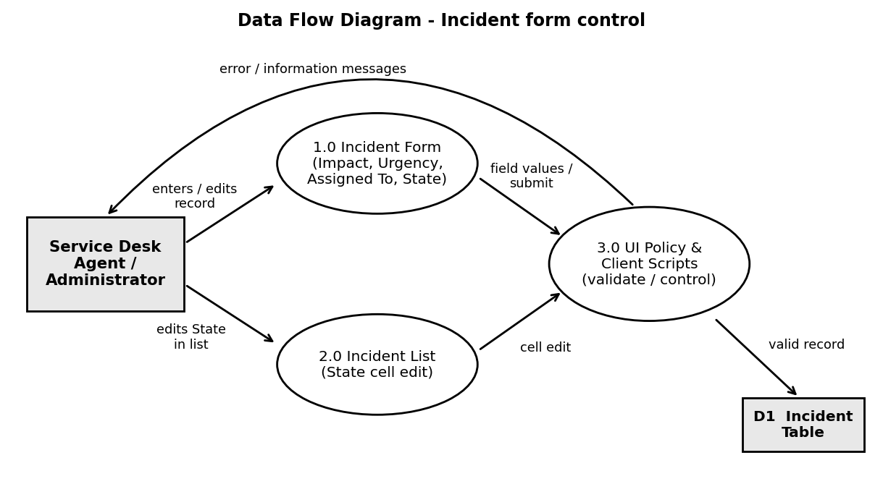
Figure 1: Data flow of the Incident form control

3.4 Technology Stack
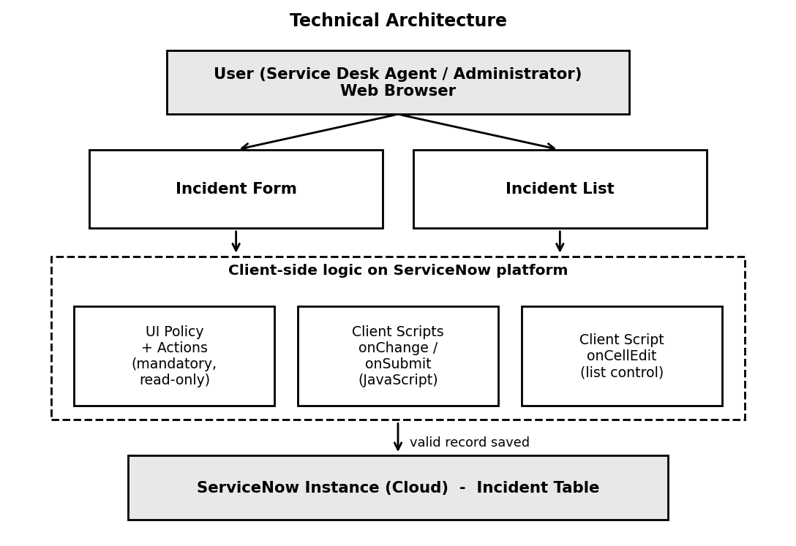
Figure 2: Technical architecture of the solution
S.No | Component | Description | Technology
1. | User Interface | Incident form and Incident list | ServiceNow Web UI in a web browser
2. | Application Logic-1 | Assignment Group mandatory and Urgency read-only when Impact is High | UI Policy and UI Policy Actions
3. | Application Logic-2 | Automatic Urgency and save validation | Client Scripts (onChange, onSubmit)
4. | Application Logic-3 | Block State change from the Incident list | Client Script (onCellEdit)
5. | Database | Incident records | ServiceNow Incident table
6. | Infrastructure | Application deployment | ServiceNow cloud instance

4. PROJECT DESIGN

4.1 Problem Solution Fit
Canvas section | Description
Customer Segment(s) | Service desk agents and support staff; administrators who maintain the Incident form.
Customer Problems / Pains | Urgency has to be set manually even when Impact is High.  Assignment Group is not enforced as mandatory.  State can be edited directly from the Incident list.
Triggers to Act | An Incident is created or updated with Impact set to High.
Emotions: Before / After | Before: records are incomplete and inconsistent. After: High Impact Incidents always have proper assignment details.
Existing Behaviour | Users enter the values manually; no validation exists on the form or the list.
Our Solution | One UI Policy with two policy actions and three Client Scripts on the Incident table.
Channels of Behaviour | Online: ServiceNow Incident form and list in a web browser.

4.2 Proposed Solution
S.No. | Parameter | Description
1. | Problem Statement (Problem to be solved) | Incorrect or incomplete data can be entered on the Incident form, Urgency is set manually, Assignment Group is not enforced, and State can be edited from the Incident list.
2. | Idea / Solution description | A UI Policy makes Assignment Group mandatory and Urgency read-only when Impact is High; Client Scripts set Urgency automatically, stop saving when Assigned To is empty, and stop State changes from the list.
3. | Novelty / Uniqueness | A UI Policy and three types of Client Script (onChange, onSubmit, onCellEdit) work together, and Reverse if false removes the restrictions automatically.
4. | Social Impact / Customer Satisfaction | Easier and less error-prone Incident form; proper assignment details for High Impact Incidents; controlled State changes.
5. | Business Model (Revenue Model) | Not a revenue-based product; a configuration project that improves the quality of Incident records.
6. | Scalability of the Solution | Can be extended to other tables such as Problem and Change Request, with more conditions such as Priority or Category.

4.3 Solution Architecture
The solution is designed as one UI Policy with two policy actions and three Client Scripts, all working on the Incident table.
Component | Type | Trigger / Condition | Action
High Impact Control | UI Policy | Impact is 1 - High | Assignment Group mandatory; reverse if false enabled
Urgency policy action | UI Policy Action | Impact is 1 - High | Urgency field set to read-only
Auto set urgency for high impact | Client Script (onChange) | Impact field changes | Urgency set to 1 - High and info message shown
Prevent save if Assigned To missing | Client Script (onSubmit) | Impact High and Assigned To empty | Error message shown, save blocked
Prevent state change via list edit | Client Script (onCellEdit) | State edited from list | Alert shown, change cancelled
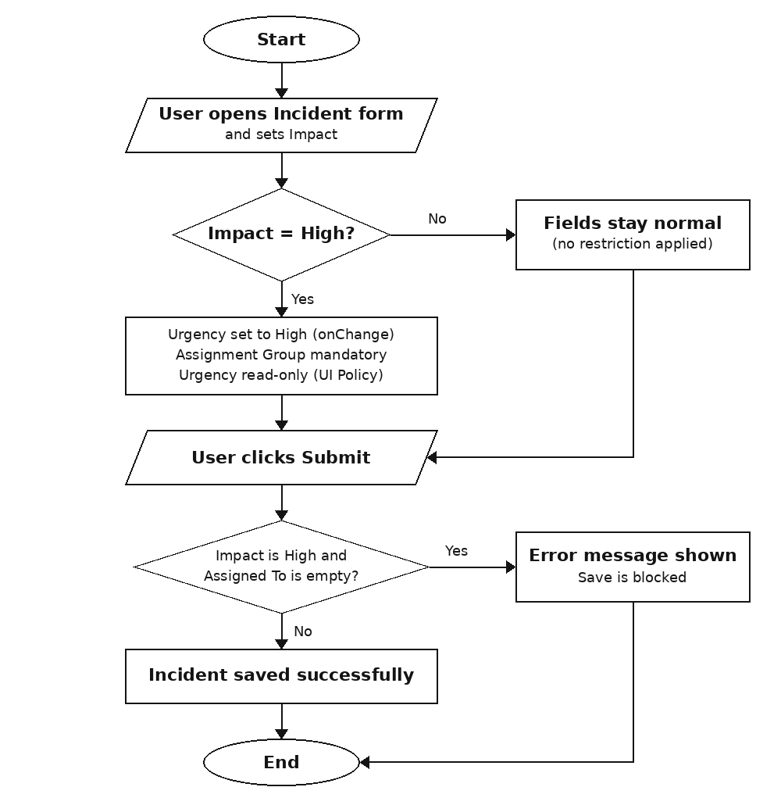
Figure 3: Incident form logic flow

5. PROJECT PLANNING & SCHEDULING

5.1 Project Planning
The project was divided into small activities. Each activity produces a working part of the solution, which is tested before moving to the next one.
Step | Activity | Description | Output
1 | Understand the requirement | Study the Incident form behaviour needed for High Impact Incidents | Requirement list
2 | Create UI Policy | Create High Impact Control policy with the Impact condition | UI Policy
3 | Add UI Policy Actions | Make Assignment Group mandatory and Urgency read-only | Policy actions
4 | Create onChange script | Auto set Urgency when Impact is High | Client Script 1
5 | Create onSubmit script | Block save when Assigned To is empty | Client Script 2
6 | Create onCellEdit script | Block State change from list | Client Script 3
7 | Test the solution | Run test cases for all conditions | Test results
8 | Prepare documentation and demo | Write the phase documents and record the demo | Report, GitHub and demo links
Sprint plan and story points:
Sprint | Epic | User Story | Story / Task | Story Points
Sprint-1 | High Impact Field Control | USN-1 | Assignment Group mandatory (UI Policy) | 2
Sprint-1 |  | USN-2 | Urgency read-only (UI Policy Action) | 1
Sprint-1 | Automatic Urgency | USN-3 | Auto set Urgency (onChange) | 2
Sprint-2 | Save Validation | USN-4 | Block save when Assigned To is empty (onSubmit) | 3
Sprint-2 | State Change Control | USN-5 | Block State change from list (onCellEdit) | 3
Sprint-2 |  | USN-6 | Allow State change from form | 1
Sprint-3 | Testing | USN-7 | Run test cases and record results | 3
Sprint-3 | Documentation and Demo | USN-8 | Prepare documents and demo | 2
Total story points = 5 + 7 + 5 = 17 in 3 sprints, so the velocity is 17 / 3 ≈ 5.7 story points per sprint.
Tools and resources: ServiceNow instance with administrator access, web browser, and GitHub for storing the project documents.
Risk | How it is handled
Rules affecting normal records | Reverse if false is used and tested with a Medium Impact record
Scripts not running as expected | Each script is tested separately after it is created
Users editing State from the list | onCellEdit script blocks it, and the form remains available

6. FUNCTIONAL AND PERFORMANCE TESTING

6.1 Performance Testing
The implemented UI Policy and Client Scripts were tested using different Incident conditions.
Test Case ID | Test Scenario | Test Steps | Expected Result | Actual Result | Pass/Fail
TC-001 | High Impact with Assigned To empty | 1. Incident > Create New  2. Impact High, Assigned To empty  3. Click Submit | Incident should not be saved | Not saved; error message displayed | Pass
TC-002 | High Impact with Assigned To filled | 1. Select a valid user in Assigned To  2. Submit | Incident should save successfully | Record saved without error | Pass
TC-003 | Impact changed from High to Medium | 1. Open a High Impact Incident  2. Change Impact to Medium  3. Submit | Previous restrictions should be removed | Assigned To not mandatory, Urgency editable | Pass
TC-004 | State changed from Incident list | 1. Incident > All  2. Double-click State of a record | State change should be blocked | Alert displayed, State unchanged | Pass
TC-005 | State changed from Incident form | 1. Open the Incident form  2. Change State, click Update | State change should be saved | Record saved successfully | Pass
TC-006 | Impact changed to High | 1. Open an Incident  2. Set Impact to 1 - High | Urgency should be set to High | Urgency set to High automatically | Pass
All six test cases passed, so the configured conditions are working properly.

7. RESULTS

7.1 Output Screenshots
Test 1 - Mandatory enforcement: an Incident with High Impact and empty Assigned To is not saved and an error message is displayed.
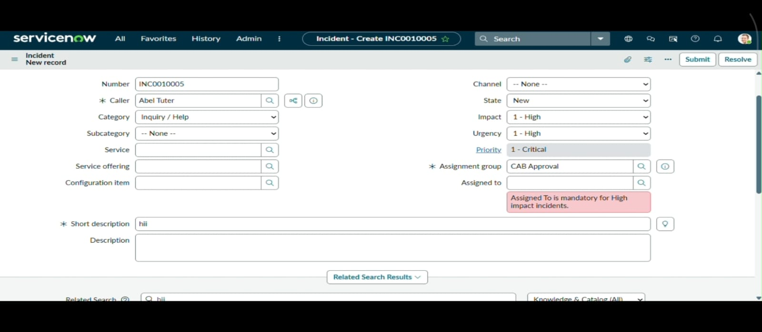
Figure 4: Mandatory field validation message
Test 2 - Successful save: after a valid user is selected in Assigned To, the Incident is saved successfully.
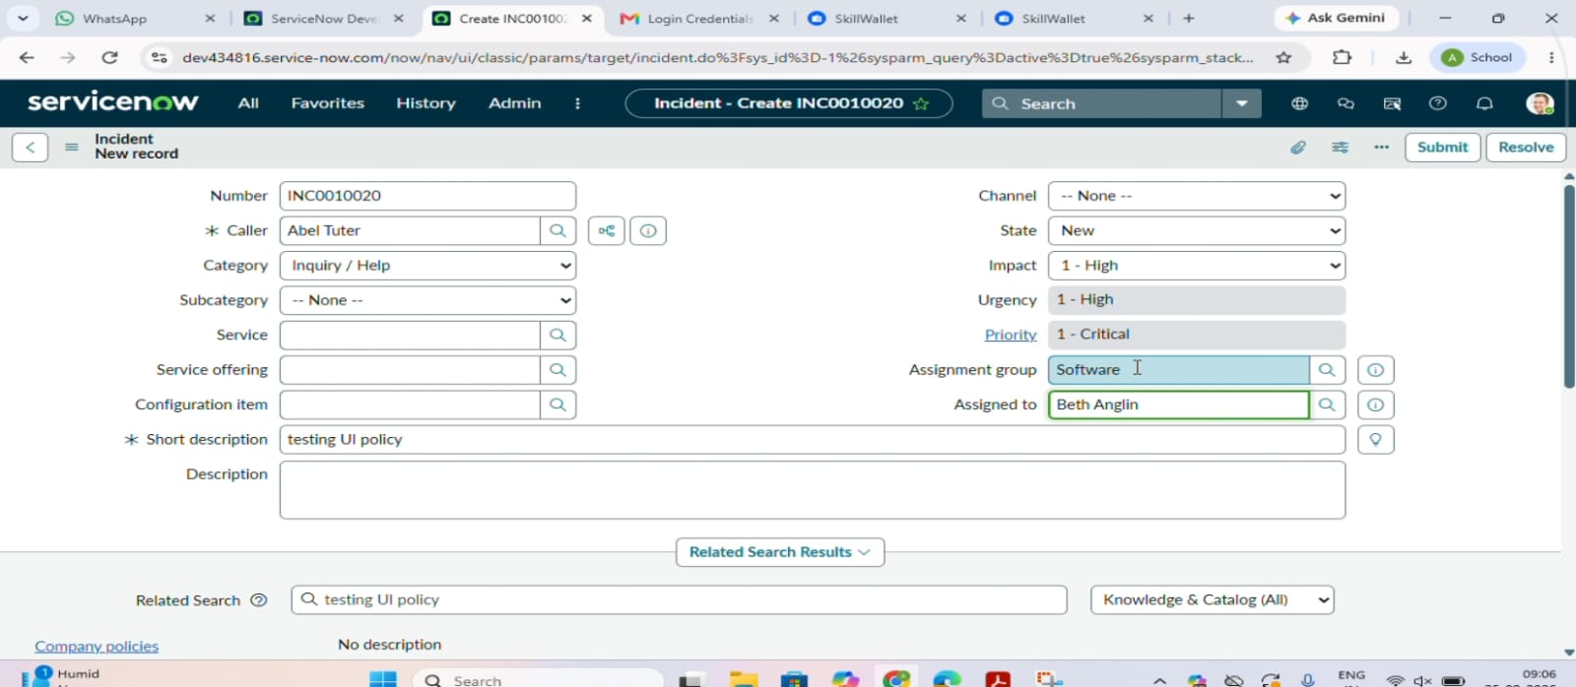
Figure 5: Successfully saved Incident record
Test 3 - Reverse condition: when Impact is changed from High to Medium, Assigned To is no longer mandatory and Urgency becomes editable.
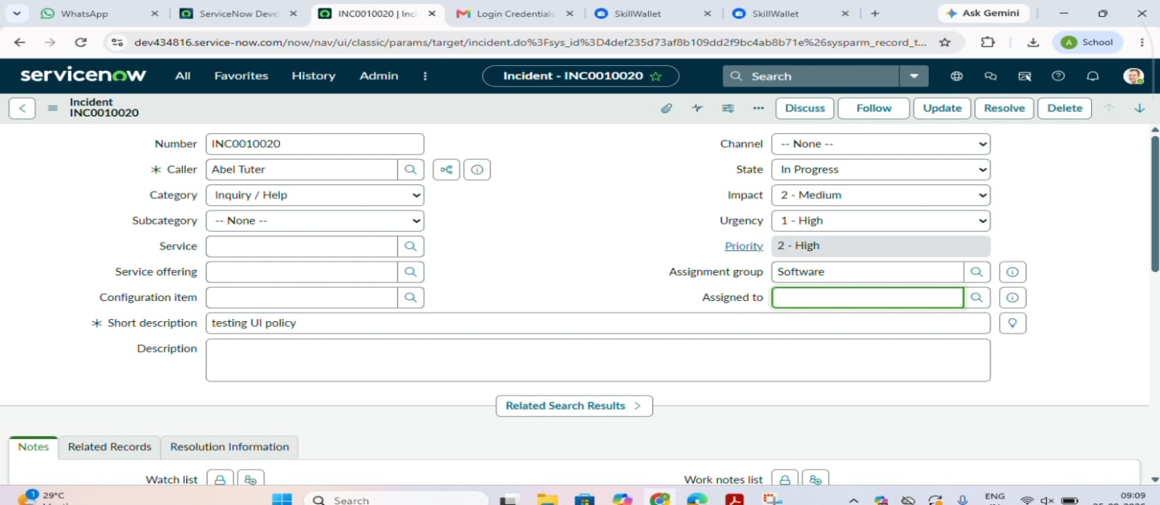
Figure 6: Reverse condition verification
Test 4 - List edit blocking: when the State field is edited from the Incident list, an alert appears and the State value remains unchanged.
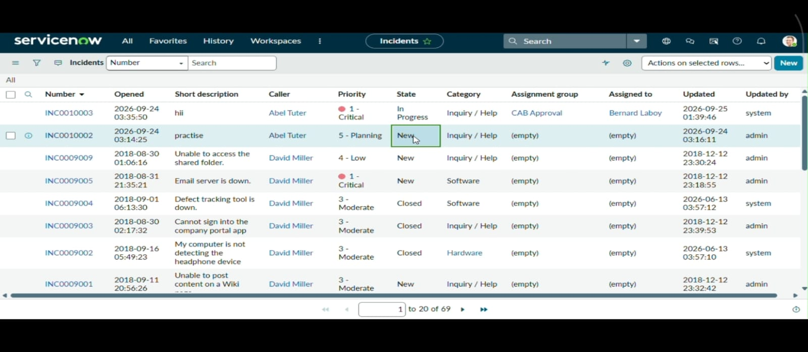
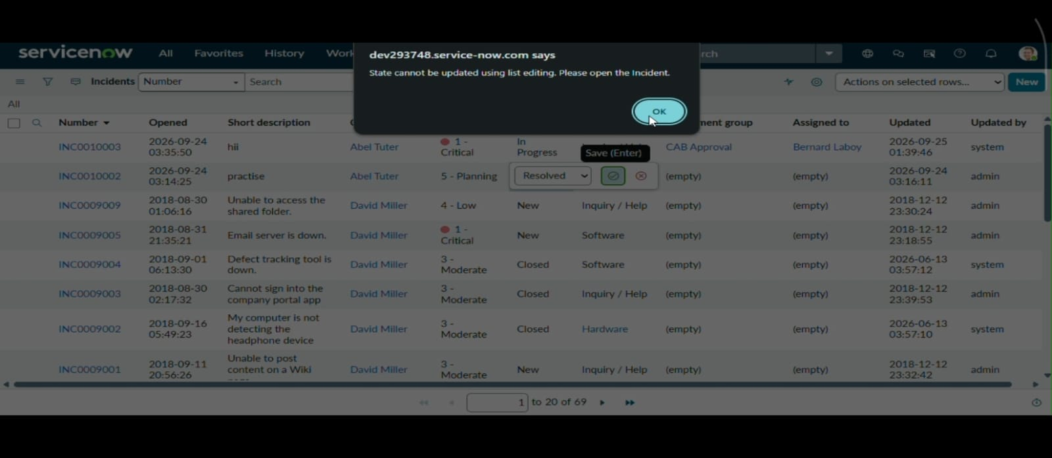
Figure 7: State list edit blocking
Test 5 - Form-based update: the State can still be changed and saved from the Incident form.
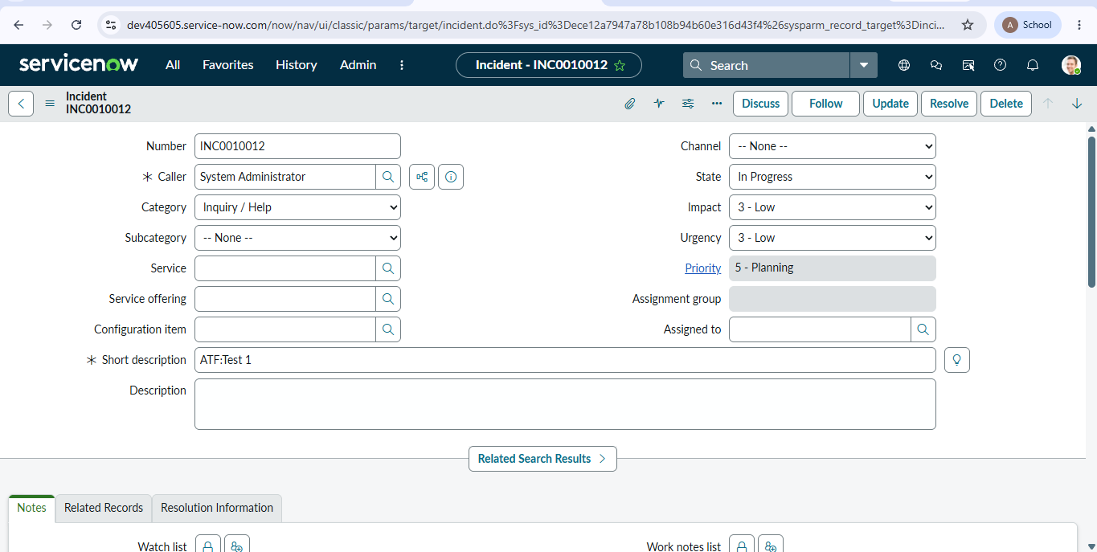
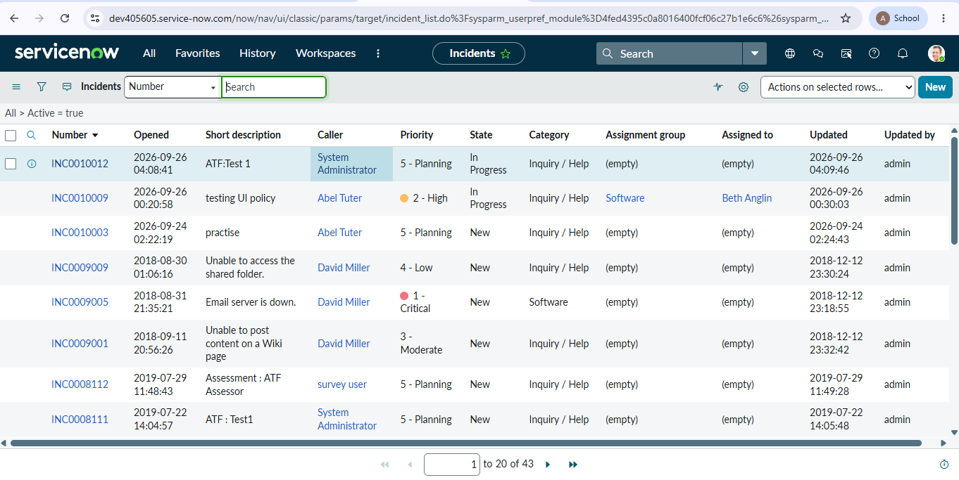
Figure 8: Successful form-based State update

8. ADVANTAGES & DISADVANTAGES
Advantages
- Client-side rules give instant feedback without waiting for the server.
- High Impact Incidents always have proper assignment details.
- Urgency is set automatically, which saves manual effort and avoids mistakes.
- State changes follow a controlled path through the Incident form.
- Reverse if false removes the restrictions automatically, so normal records are not affected.
- Only standard ServiceNow tools are used, so the configuration is easy to modify.
Disadvantages
- The project is limited to the Incident table only.
- The rules are based on a single condition, Impact being High, and do not cover combinations such as Priority or Category.
- Client-side controls run in the browser, so they do not replace server-side rules for records changed by other means.

9. CONCLUSION
The Client Scripts and UI Policy were successfully created and implemented for the ServiceNow Incident table. The system automatically sets the Urgency when the Impact is High, checks the Assigned To field before saving, and prevents State changes through direct list editing. The reverse condition was also tested successfully: when the Impact is changed from High to Medium, the required conditions are removed and the normal field behavior is restored.
The project helped to understand how UI Policies and Client Scripts can be used in ServiceNow. Different Client Script types such as onChange, onSubmit, and onCellEdit were used for different purposes, and the UI Policy was used to control fields based on the Impact value. All the tests were successful and the configured functions worked as expected.

10. FUTURE SCOPE
- Extend the same approach to other tables such as Problem and Change Request.
- Add more conditions based on Priority, Category, or Assignment Group.
- Integrate notifications or approvals so that High Impact Incidents are escalated automatically.

11. APPENDIX

Source Code (if any)
The solution is created with ServiceNow configuration (UI Policy and Client Scripts) directly in the instance. The scripts as created are shown in the screenshots below.
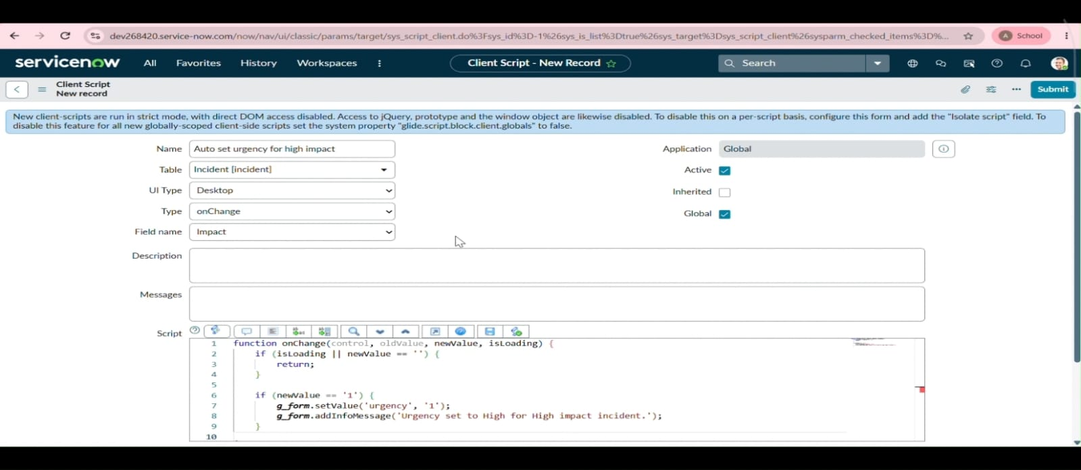
Client Script: Auto set urgency for high impact (onChange)
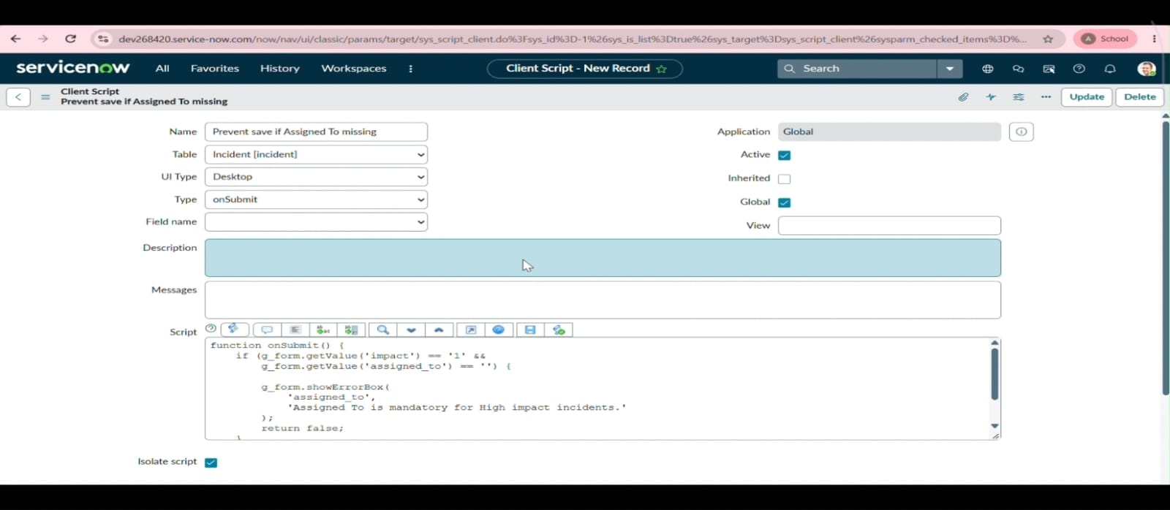
Client Script: Prevent save if Assigned To missing (onSubmit)
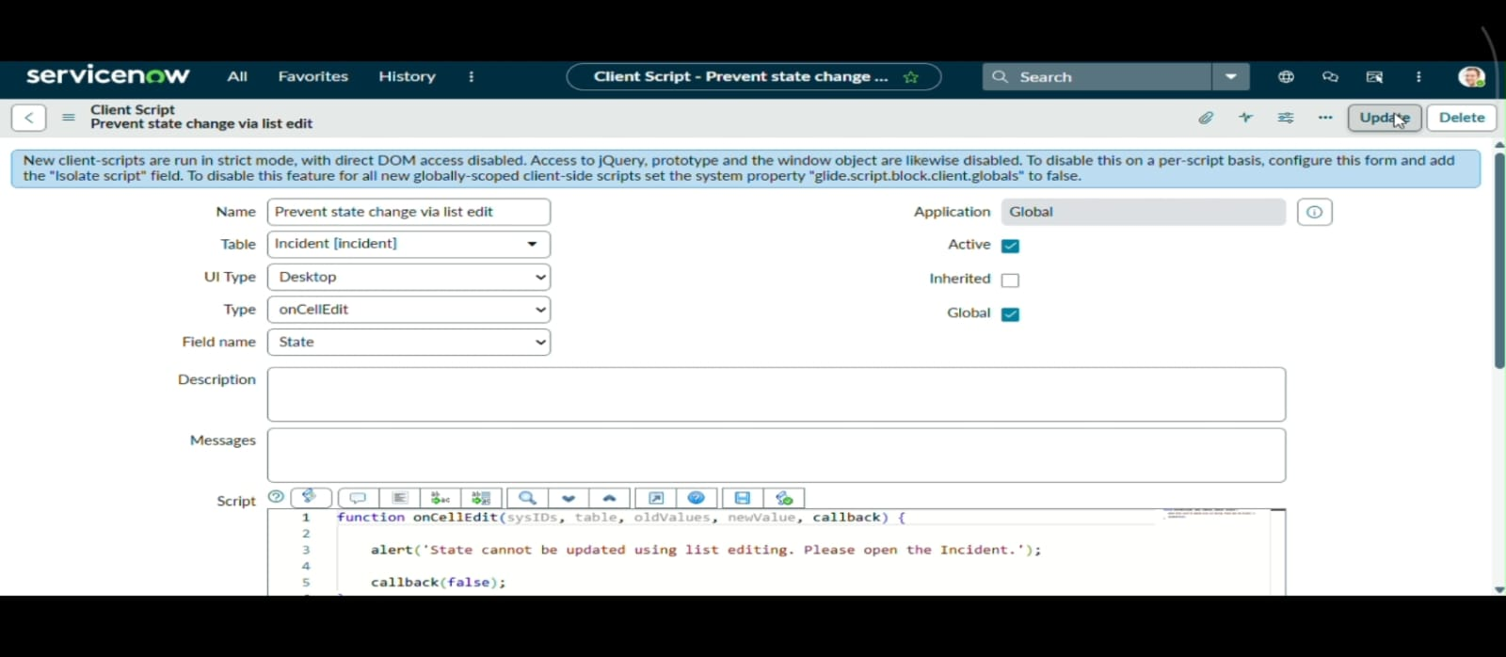
Client Script: Prevent state change via list edit (onCellEdit)
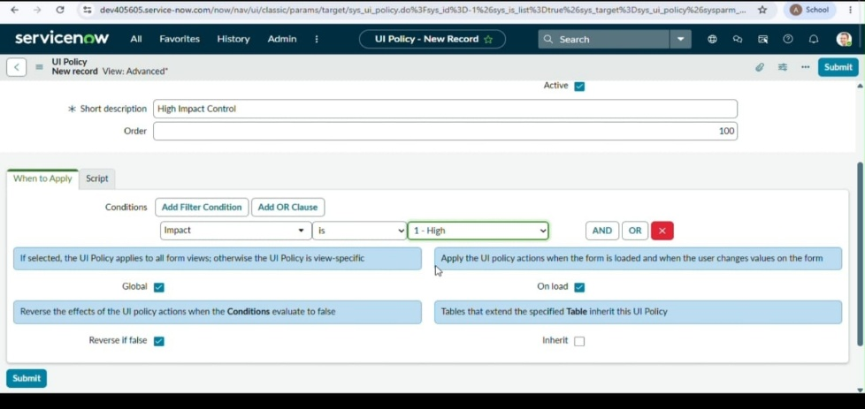
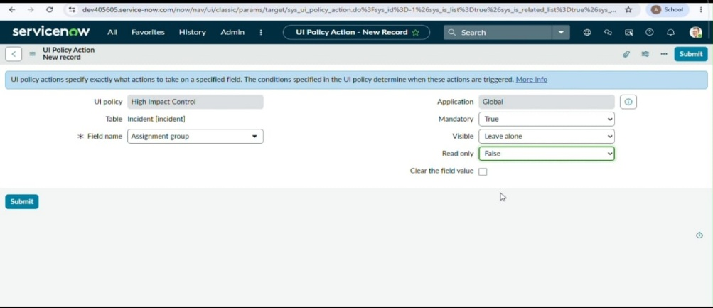
UI Policy: High Impact Control and its Assignment Group action
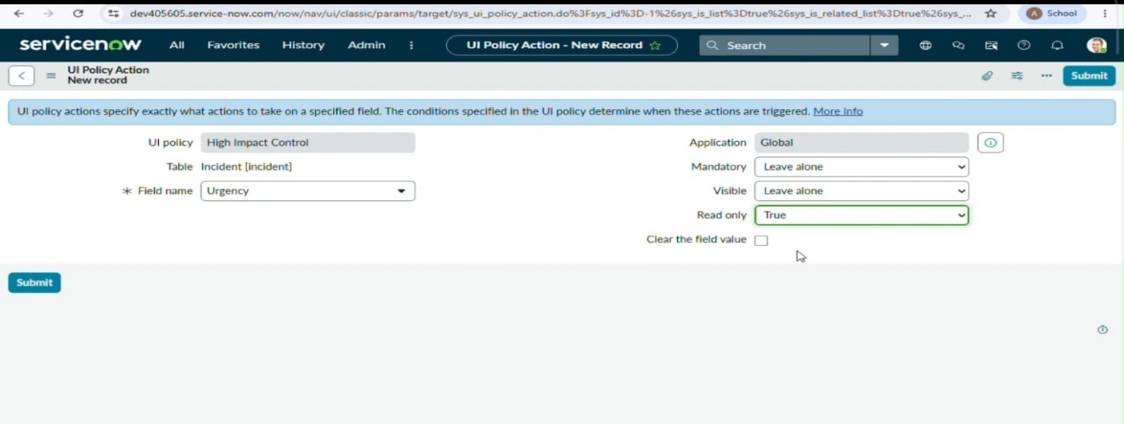
UI Policy Action: Urgency read-only

Dataset Link
Not applicable. No external dataset is used in this project.

GitHub & Project Demo Link
Item | Link
GitHub Project Link | https://github.com/anirosita-m/Implement-Client-Script-UI-Policy---Incident-ServiceNow-
Project Demo Link | https://drive.google.com/file/d/120MGLkj8_Jj_Z8GnTAFwjECGm7_3bgVb/view?usp=sharing

